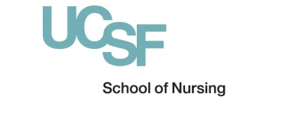
Submit application to:

Mary McQuilkin, NP, MPH
mary.mcquilkin@ucsf.edu
Assistant Clinical Professor
Community Health Systems

HIV MINOR APPLICATION

This application is required for students who wish to participate in the HIV Minor. Please submit the completed form to Mary McQuilkin. Participants in the Minor must meet the following eligibility criteria:
- Admission to a UCSF Master of Science Program
- Good academic standing
- Approval from academic advisor
- Agreement to complete the HIV courses and clinical requirements
Students may modify their course of study to include the HIV curriculum using the online student portal. Any student may take SON HIV courses as electives, which does not require completion of this form.

SECTION 1: STUDENT INFORMATION

Student Name: _____________________________ Advisor’s Name: ____________________________

Program (ie AGNP or FNP): _______________ Expected Graduation Date: ______________________

SECTION 2: STUDENT BACKGROUND & GOALS

A. Briefly describe your professional, personal, and/or educational backgrounds as they relate to your desire to participate in the HIV Minor. Please limit your response to 300 words.

B. Briefly describe your goals for completing the HIV Minor. Please limit your response to 300 words.

SECTION 3: STUDENT SIGNATURE

I certify that all the information given on this application is complete and true, and my own original work.

_________________________________________ _____________
Student Signature Date

